Creating an Installer

## Requirements

To create an installer the following programs/packages must be installed. Install the proper version for the platform being used (i.e. 32 bit vs. 64 bit, Python 2.7, Windows):

* 7-zip version 9.20 from <http://www.7-zip.org/>
* Qt version 4.8.5 from <http://qt-project.org/downloads>
* PySide version 1.2.1 from <http://qt-project.org/wiki/PySideDownloads>
* cx_Freeze from <http://cx-freeze.sourceforge.net/>

It also may be necessary to expand all the Python egg modules in the site-packages Python directory

## Instructions

* Select the release version of the certification tool to be used (X.Y)
* Select the release version of the test suite to be used (A.B)
* Select the release version of wCAT to be used (M.N)
* Install the selected released version of the certification tool
* Create a directory named wCATM.N-tX.Y-sA.B, where M.N is the release version of wCAT utility, X.Y is the released version of the certification tool and A.B is the released version of the test suite to be used.  
  For example wCAT1.0-t1.1-s2.01 will include wCAT version 1.0, the released version 1.1 of the certification tool and the released version 2.01 of the test suite
* Export (svn) the trunk_wcat from the selected release version into the newly created directory
* Export (svn) the test suite scripts from the selected release version of the test suite to the checked out ‘scripts’ directory
* Export (svn) the all the ‘trunk_scripts/datamodel’ files from the selected release version of the test suite to the checked out ‘datamodel’ directory
* Move ‘default_server.py’ from the ‘datamodel’ directory to the ‘server’ directory
* Export (svn) the schema directories under ‘trunk\src\wsvt\schemas, to the checked out ‘witsml_files/schemas’ directory
* Update the versions define in the file ‘src/wcat.py’ with the selected release versions

TEST_PLAN_VERSION = '1.0'

CERTIFICATION_TOOL_VERSION = '1.2.3'

CERTIFICATION_TEST_SUITE_VERSION = '2.01'

* Open a command window and go to the created directory and run the following commands

cxfreeze src\wcat.py --target-dir dist --include-modules=lxml.etree,lxml._elementpath,pytz,iso8601

cxfreeze datamodel\data_grower_script.py --target-dir=dist2 --include-modules=lxml.etree,lxml._elementpath,pytz,iso8601

cxfreeze datamodel\load_data_set.py --target-dir=dist3 --include-modules=lxml.etree,lxml._elementpath,pytz,iso8601

* Move all the contents from the newly created directories ‘dist’, ‘dist2’ and ‘dist3’ to the created directory. Some files will exist in multiple directories (dist, dist2, dist3). It is ok to overwrite those files when moving a directory.
* Copy all the .png files from the ‘src’ directory to the created directory
* Remove the directories ‘dist’, ‘dist2’, ‘dist3’ and ‘datamodel’
* Remove ‘Installer Instructions.docx ‘ (this file) from the doc directory
* Zip the created directory with 7-zip using the option “Create SFX archive”

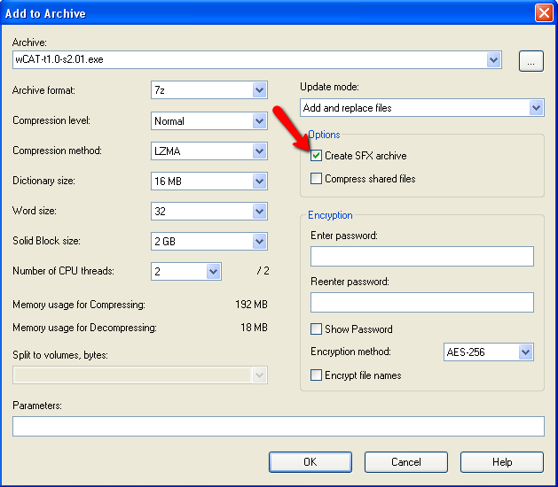

Note: A different utility than 7-zip could be used to create the self extracting installer if desired

Note: The installation instructions in ‘wCAT Manual.docx’ should be copied and provided together with the installer file